See what the Lord has done! Count your many blessings and see what the Lord has done!

Greetings to all my Sisters and Brothers

We want to welcome each of you who join us today as our special guest. You join us today as a VIP because of your contribution to the equipping of the saints to carry out the work of the Lord! You called into the Ministry line and said “I am here” or you joined in-person sessions such as Joyful Friday or Thankful Thursdays, led our Walk in the Word sessions, prayed, sung songs of praise, and lifted hymns of our forefathers, gave encouraging feedback, and yes my brothers and sisters you preached. Many of you as Disciples of Christ showed up with pen, paper and your Bibles ready to receive the instructions provided in the Discipleship Classroom. Instructions that make us the disciples with purpose aligning to the mission. Sessions that stretched us to ask what more can I do for the Kingdom of God? Causing us to ask ourselves do I have a Kingdom mindset? Less than a year ago we gathered at 3950 Hartness Drive for our first Ministries in Partnership thank you fellowship. Oh, what a time we had. The best of food, fellowship, walk down memory lane of old spirituals, and yes, the Word! As we look around today, some faces and chairs are empty. And I would be remiss if I did not mention the name of those Ambassadors Brother Marshall “Helicopter” Turner, Deacon Luther “Mission Accomplished” Williams. We want their families to know we have not forgotten them nor you.

**So, Some may be asking today what is this ministry in partnership? I am glad you asked**

**Here’s a snippet of our history at a glance**

It started with Out of the Box Ministries. This ministry was established in October 2011 by Minister Terry Oliver, Sr. with the following initial post to Facebook sent by him.

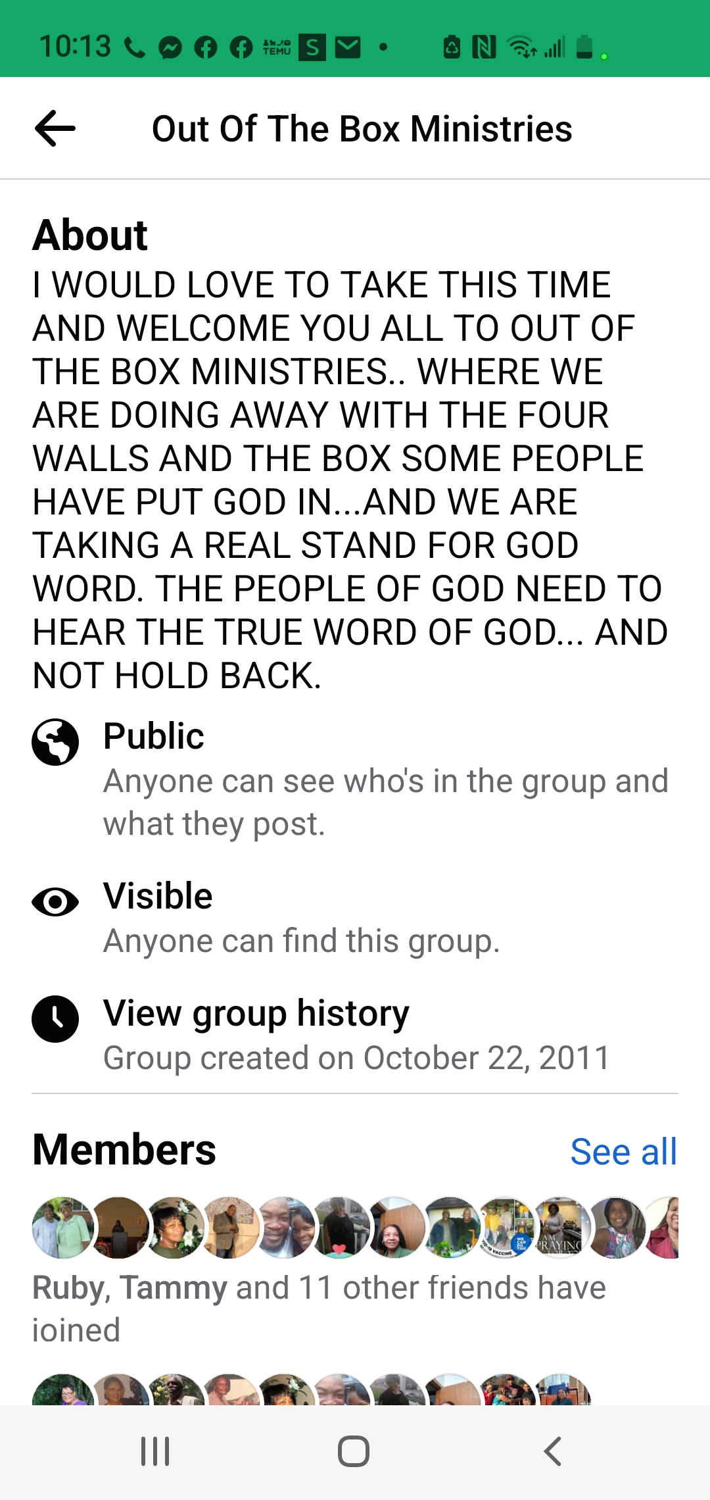

Even though Minister Terry Oliver, Sr was promoted to his heavenly home in December 2018 the ministry continues to strive. The ministry has grown tremendously since 2011, including partnering with four additional ministries: The Gathering Place-Beyond the Walls, Inc. (Minister Debra Singleton), The Gates of Prayer Tabernacle (Apostle Alean Aside), The Enlightment Ministry (Pastor Reginald Kiper) and supported by Manna of Hope Resource Center (Minister Mary Whitfield). The partnership of ministries continues with the 3Ps (**P**raise, **P**rayer, **P**reaching) plus an **E** equipping the disciples of Christ for Kingdom Work. This is accomplished through the Word of God with a weekly Tuesday Walk in the Word, a Sunday evening Praise, Prayer, and Preaching Time, a Sunday Morning Walk in the Word, a Joyful Friday Session, and a Thursday Walk in the Scriptures. And weekly evangelistic opportunities in the trenches of our local community Elm Street, Walnut, Martin Luther King, Jr., covalent homes and senior living homes, etc. The Ministry walks in the commission given in Matthew 28:19-20 in making disciples for Christ. **19**Therefore go and make disciples of all nations, baptizing them in the name of the Father and of the Son and of the Holy Spirit, **20**and teaching them to obey everything I have commanded you. And surely, I am with you always, to the very end of the age.”

The Ministry is also committed to carrying out Matthew 25:35-40: **35**For I was hungry and you gave me something to eat, I was thirsty and you gave me something to drink, I was a stranger and you invited me in, **36**I needed clothes and you clothed me, I was sick and you looked after me, I was in prison and you came to visit me.’ We have done this through outreach efforts as far as Alabama for those who lost their homes and belongings through fire, storm damages, etc., local efforts include: feeding individuals displaced, providing school supplies, providing household and hygiene items, cards to the incarcerated, bus passes, etc. This ministry partnership continues to reach across states and cities to touch hearts, minds, and souls.

We take our hats off to Sister Ruby for facilitating this ministry partnership event. Thank you so much again Sister Ruby for resuming the Out of the Box Ministry teleconference line and hosting such a beautiful second gathering of supporters on the line. Again, our hats off to you! Our utmost desire is to Love God, Serve God by aligning to His will, way and Word and love and serve His people! We look forward to the future to do more for the Lord as His ambassadors!

John 14:11-13 says:

New International Version

11 Believe me when I say that I am in the Father and the Father is in me; or at least believe on the evidence of the works themselves. 12 Very truly I tell you, whoever believes in me will do the works I have been doing, and they will do even greater things than these, because I am going to the Father. 13 And I will do whatever you ask in my name, so that the Father may be glorified in the Son.

The best is yet to come! Thank you, Lord for our journey!